
LA CONSOLACION COLLEGE-PASIG
641 Mercedes Avenue, Brgy. San Miguel, Pasig City
LEARNING PLAN
S.Y. 2026-2027
Subject: Science |  | Grade Level: Kinder 2 |  |  | Date Coverage: Week 6 Term 1  June 27 – 31, 2026
I Learning Objectives: At the end of the lesson the students will be able to:  - Listen to a story about communication tools  - Name different communication tools and technology in a story  - Tell how to use communication tools properly  - Create digital story |  |  | II Subject Matter  Lesson: Learning About Communication Tools and Technology  Reference/s: Early Beginnings: Science Kinder worktext
III - Learning Competencies:
- Demonstrate awareness of tools for communication
III- Values Statement:
- God gave us communication tools so we can share love, respect with others and connect to our love ones even if its afar.
IV- Procedures:
a. Routine Activities

- Prayer
- Attendance
- Circle Time

b. Motivation:
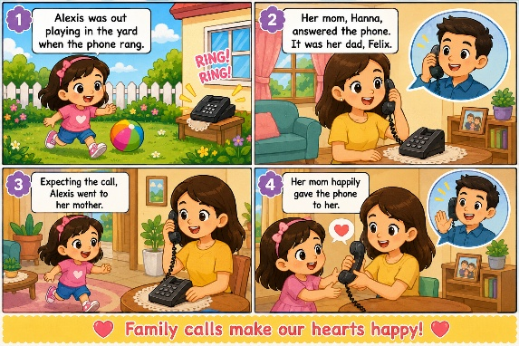

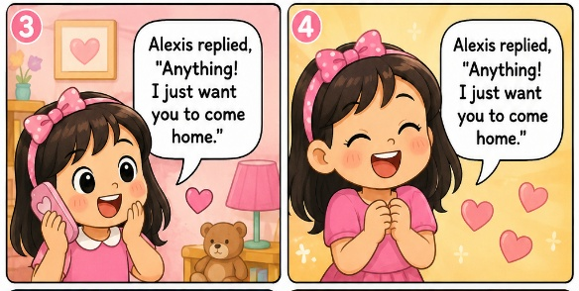

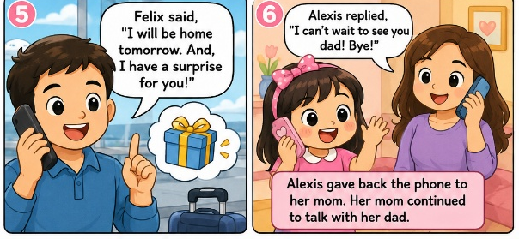
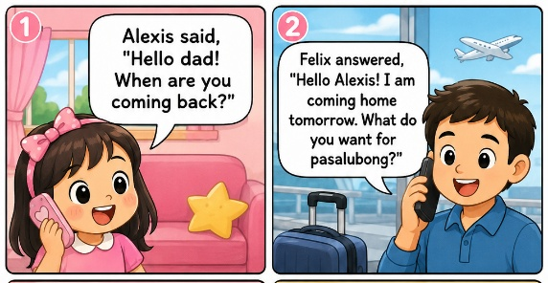

c. Learning Strategies
Show and Tell – The teacher will show different communication tools and the students will tell the name of communication tools and its use.



V- Assessment:
- Check communication tools
- Color communication tools use in the story

VI- Closure: The teacher will remind the students about the proper use of communication tools.
VII- Assignment: Create digital story (Learning beyond, Page 47)

Remarks:
Prepared by:  Ms. Kathrynn Ross L. Acola | Checked by:  Mrs. Emma P. Dunque Lpt. |  |  | Observed by:  Mrs. Emma P. Dunque Lpt.

LA CONSOLACION COLLEGE-PASIG
641 Mercedes Avenue, Brgy. San Miguel, Pasig City
LEARNING PLAN
S.Y. 2026-2027
Subject: Science |  | Grade Level: Kinder 2 |  |  | Date Coverage: Week 2  June 22-26, 2026  Term 1
I Learning Objectives: At the end of the lesson the students will be able to:  - Name the basic parts of the body:  - Tell the use of each basic body part:  - Recite a rhyme about parts of the body; and draw his/her favorite body part. |  |  | II Subject Matter  Lesson: Learning About My Body Parts  Reference/s: Early Beginnings: Science Kinder worktext
III- Values Statement:
Caring for the body as gift of the God
IV- Procedures:
a. Routine Activities
- Prayer
- Attendance
- Circle Time

b. Motivation:
Dance and Sing: “Head, Shoulders, Knees, and Toes
Guide Question:
- Who gave us our body?
- How do we take care of our body?
- What body parts did we touch while dancing?

c. Learning Strategies
Demonstration – The teacher will show a picture of Part of the body
Instruction – Afterwards the teacher can ask them about different part of the body and their uses.
Art of questioning –
- Why is each body part important?
- How can we take care of our body?

V- Assessment:
- Oral -naming of the body parts and their use in everyday life.
- Drawing and coloring a favorite body part.
VI- Closure:
- Recap body parts, students will point to one body part and say the use of that body parts.
VII- Assignment:
- Video Record The students will make a short video using their body, showing the body parts they use and telling the movements they are doing, such as jumping up and down, singing a song, combing their hair, or dancing to music.
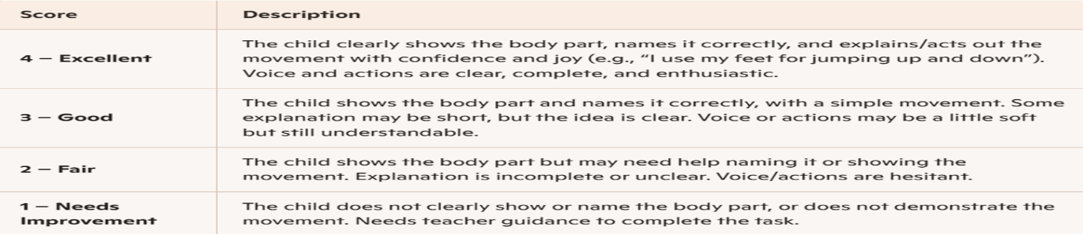

Remarks:

Prepared by:  Ms. Kathrynn Ross L. Acola | Checked by:  Mrs. Emma P. Dunque Lpt. |  |  | Observed by:  Mrs. Emma P. Dunque Lpt.

LA CONSOLACION COLLEGE-PASIG
641 Mercedes Avenue, Brgy. San Miguel, Pasig City
LEARNING PLAN
S.Y. 2026-2027
Subject: Science |  | Grade Level: Kinder 2 |  |  | Date Coverage: Week 3 –  July 6-10, 2026  Term 1
I Learning Objectives: At the end of the lesson the students will be able to:  - Identify 5 senses  - Tell the importance of 5 senses  - Tell about the shapes, size, and color using different sizes  - Make a collage of cutouts showing how your senses work |  |  | II Subject Matter  Lesson: Learning about the senses  Reference/s: Early Beginnings: Science Kinder worktext
III- Values Statement:
- I use my eyes, ears, nose, tongue, and hands to learn about the world. I take care of my senses and respect how others use theirs too.
IV- Procedures:
a. Routine Activities
- Prayer
- Attendance
- Circle Time

b. Motivation:
- The students and teachers will sing and dance about the five senses.

c. Learning Strategies
Play based – The teacher will discuss first the five senses and then give the game.
Instructions: The teacher will play the simon says touch your nose and what is the senses of the nose, until all the part of the senses will called.
V- Assessment:
- Matching Activity
- Check the correct body parts
- Draw the sense organ
VI- Closure:
The teacher will again sing the song and ask students about the senses, the teacher will point all the body parts and ask students for their senses.
VII- Assignment:
- Collage cut out pictures of objects with the same color
Remarks:
Prepared by:  Ms. Kathrynn Ross L. Acola | Checked by:  Mrs. Emma P. Dunque Lpt. |  |  | Observed by:  Mrs. Emma P. Dunque Lpt.

LA CONSOLACION COLLEGE-PASIG
641 Mercedes Avenue, Brgy. San Miguel, Pasig City
LEARNING PLAN
S.Y. 2026-2027
Subject: Mathematics |  | Grade Level: Kinder 2 |  |  | Date Coverage: Week 1 –  June 22-26, 2026  Term 1
I Learning Objectives: At the end of the lesson the students will be able to:  - Say the name of the shapes  - Describe objects by telling their shapes  - Tell the shapes of the objects  - Sort objects based on their shapes  - Join matching game and;  - Paste different shapes to form a human figure |  |  | II Subject Matter  Lesson: Learning about the Shapes  Reference/s: Early Beginnings: Mathematics Kinder worktext
III- Values Statement:
- I use numbers and shapes to learn and solve problems. I try my best in counting and thinking, and I respect my classmates as we learn together.
IV- Procedures:
a. Routine Activities
- Prayer
- Attendance
- Circle Time

b. Motivation:
- The learners will watch the alphabets song about the shapes afterwards the teacher will ask the learners to name the shapes.

c. Learning Strategies
Practice and Drill – The teachers will give different shapes to the learners and ask them to name it.
Play base – The teacher will ask the learner to find a shapes around the classroom.
V- Assessment:
- Put a circle on the shape of the given objects
- Put a square on the objects that match the shapes on the left.
VI- Closure:
- The teacher will ask again about the shapes.
VII- Assignment:
- Make a picture of yourself using different shapes. Ask an adult to help you cut out and paste the shapes.
Remarks:
Prepared by:  Ms. Kathrynn Ross L. Acola | Checked by:  Mrs. Emma P. Dunque Lpt. |  |  | Observed by:  Mrs. Emma P. Dunque Lpt.

LA CONSOLACION COLLEGE-PASIG
641 Mercedes Avenue, Brgy. San Miguel, Pasig City
LEARNING PLAN
S.Y. 2026-2027
Subject: Mathematics |  | Grade Level: Kinder 2 |  |  | Date Coverage: Week 2 –  June 29-July 03, 2026  Term 1
I Learning Objectives: At the end of the lesson the students will be able to:  - Describe the size, height, or length of objects;  - Identify objects as big. small, tall, long, or short;  - Arrange objects by size, height, or length;  - Compare objects by size, height, or length; and  - use cut-out pictures of myself to make a comparison chart. |  |  | II Subject Matter  Lesson: Learning about the Shapes  Reference/s: Early Beginnings: Mathematics Kinder worktext
III- Values Statement:
- I use numbers and shapes to learn new things. I try my best to solve problems, and I respect my classmates as we work and count together.
IV- Procedures:
a. Routine Activities
- Prayer
- Attendance
- Circle Time

b. Motivation:
- The teachers will show a picture of different things and compare it into Small or Big, Tall or Short, Long and short.

c. Learning Strategies
Practice and Drill – The teachers will demonstrate a different size and give example too.
V- Assessment:
- Compare then put a box on the correct picture
- Draw the missing picture
- Arrange the objects based on their size, height, and length. Write 1,2, and 3 inside the box.
VI- Closure:
- The teacher will sing a song about sizes, length and height.
VII- Assignment:
- Paste your baby picture and your most recent picture. Look at booth pictures and see how you have changed. Then, complete the sentence on the next page.
- I am because or taller now because___________________

Remarks:
Prepared by:  Ms. Kathrynn Ross L. Acola | Checked by:  Mrs. Emma P. Dunque Lpt. |  |  | Observed by:  Mrs. Emma P. Dunque Lpt.

LA CONSOLACION COLLEGE-PASIG
641 Mercedes Avenue, Brgy. San Miguel, Pasig City
LEARNING PLAN
S.Y. 2026-2027
Subject: Mathematics |  | Grade Level: Kinder 2 |  |  | Date Coverage: Week 3 –  July 6-10, 2026  Term 1
I Learning Objectives: At the end of the lesson the students will be able to:  - Name the things used for nonstandard units of measurement; and  - Measure things or objects using nonstandard units. |  |  | II Subject Matter  Lesson: Learning about Nonstandard Measure  Reference/s: Early Beginnings: Mathematics Kinder worktext
III- Values Statement:
- I use simple objects to measure and compare things. I try my best to be careful and fair, and I respect my classmates’ work as we measure together.
IV- Procedures:
a. Routine Activities
- Prayer
- Attendance
- Circle Time

b. Motivation
- The students will recite the rhyme on page 19
- The teacher will show a picture and measure a tree
- How many arms are used to measure this tree?
c. Learning Strategies
Practice and Drill – The teachers will demonstrate a different object as nonstandard tools and discuss it.
Instructions: We can measure things using other objects, not just rulers. These objects are called nonstandard tools. Use straw, pencil, or blocks to measure big items. Use rubber, eraser or paper clips to measure small items.
V- Assessment:
- Name the nonstandard tools for measurement. Draw a line to match the picture to its name.
- Put a circle on the correct measurements of the objects below.
VI- Closure:
- Recap about the nonstandard measure.
VII- Assignment:
Choose an object to measure. Pick a nonstandard tool to measure it. Measure the object using the nonstandard tool you picked. Draw or paste pictures of the object and the tool. Then, finish the sentences below your work.

This is a___________.
It is long ____________.

Remarks:
Prepared by:  Ms. Kathrynn Ross L. Acola | Checked by:  Mrs. Emma P. Dunque Lpt. |  |  | Observed by:  Mrs. Emma P. Dunque Lpt.

